MSSV: 1815060002

Họ Tên: Đặng Ngọc Duy

Lớp: 18HTHA1

CÔNG CỤ VÀ MÔI TRƯỜNG PHÁT TRIỂN PHẦN MỀM

SELENIUM

1. **Test suite, Test case site gruru99 và Nguyễn Kim**

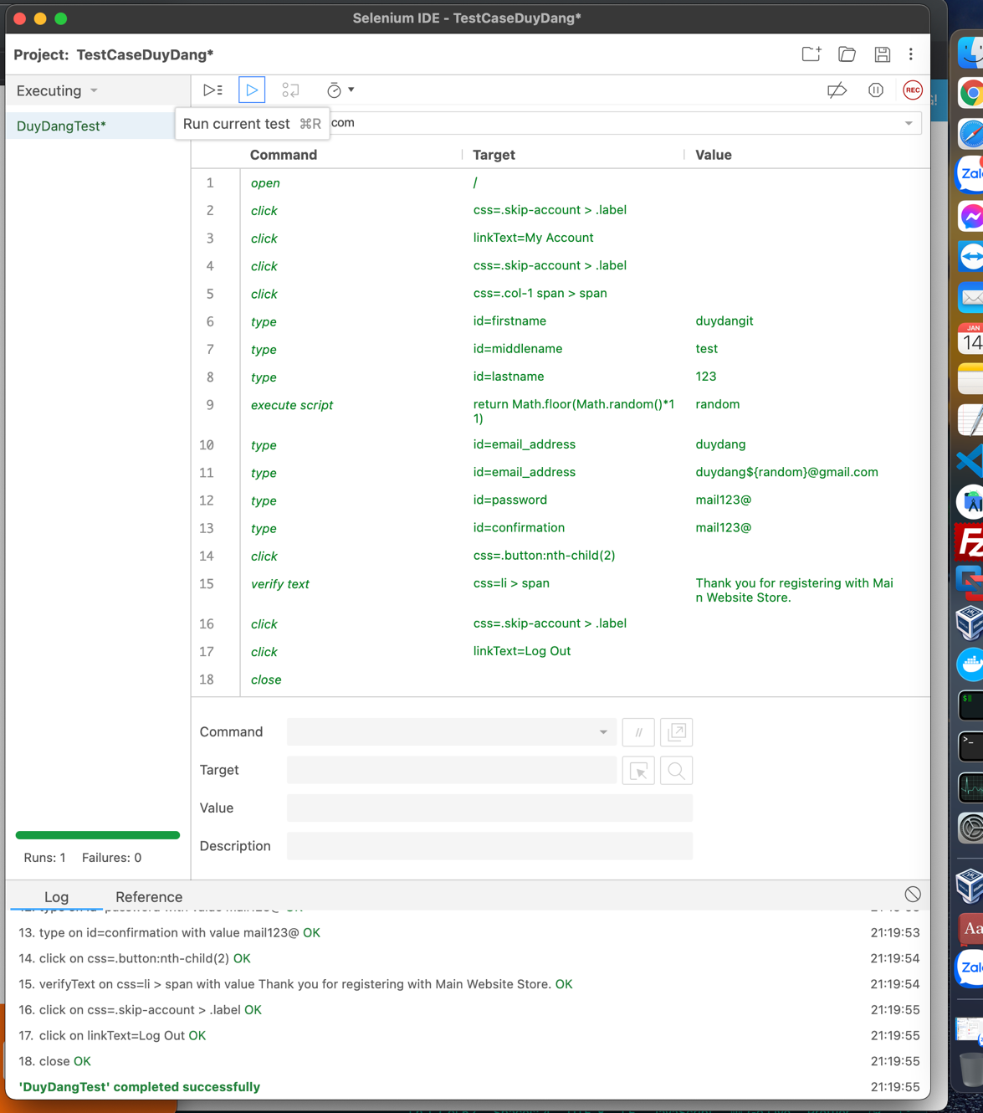

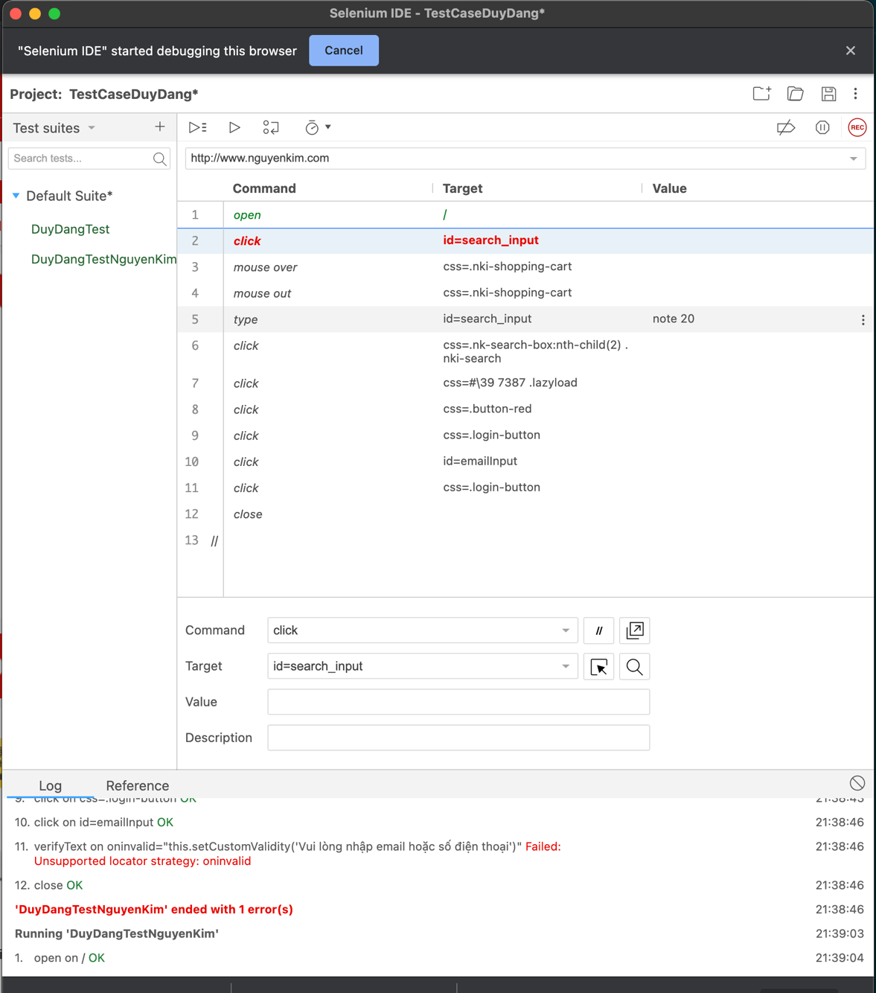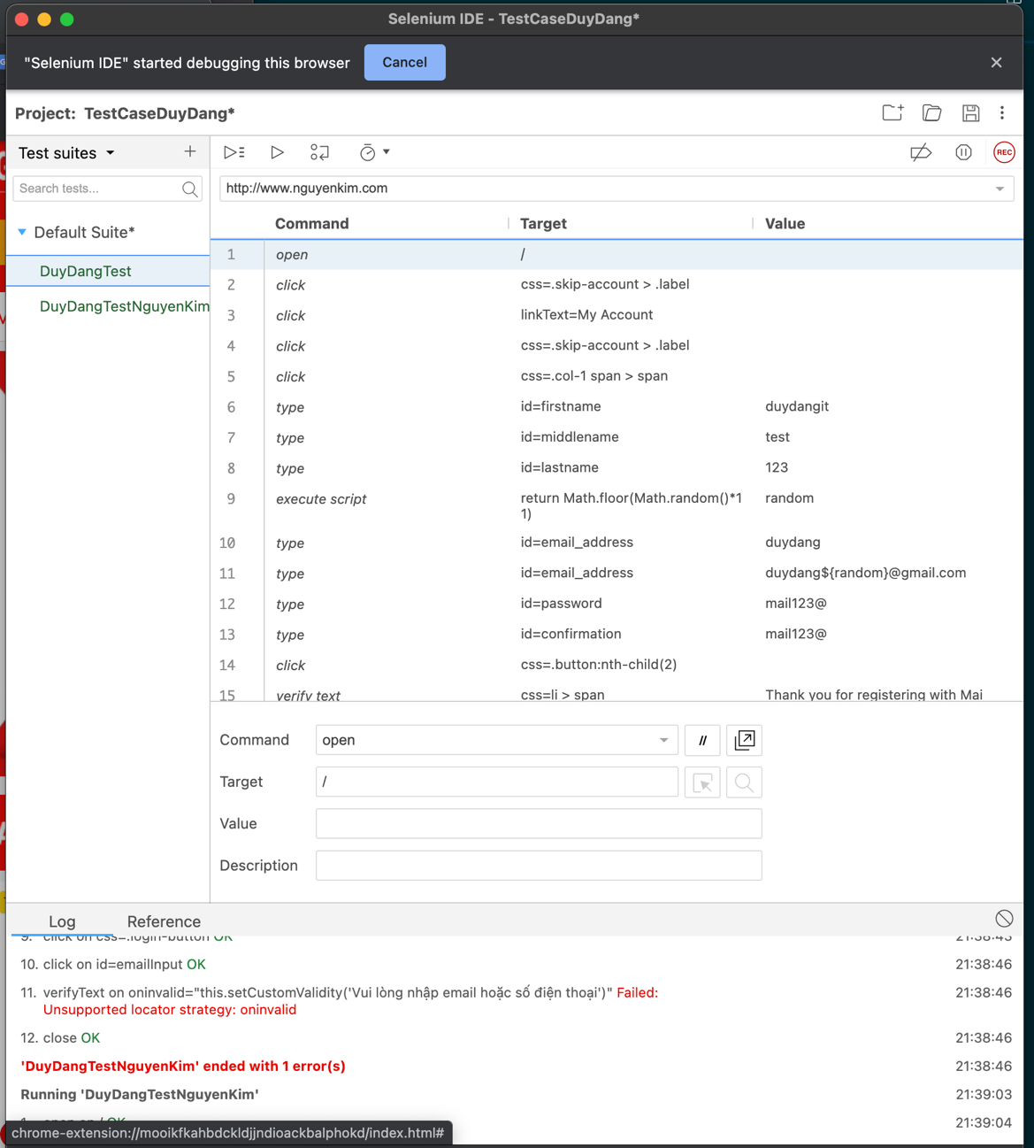

1. **Test project export**

{

"id": "8bdeabb0-eace-4315-95ef-5dd9dfe9be0d",

"version": "2.0",

"name": "TestCaseDuyDang",

"url": "http://www.nguyenkim.com",

"tests": [{

"id": "de320cf9-db67-4ef4-98db-f0e504c91c5d",

"name": "DuyDangTest",

"commands": [{

"id": "f6e6bf9b-bc8d-41ed-92e6-a6962afe36b4",

"comment": "",

"command": "open",

"target": "/",

"targets": [],

"value": ""

}, {

"id": "87c26b5b-f9ea-46bc-8f8d-c216681992d1",

"comment": "",

"command": "click",

"target": "css=.skip-account > .label",

"targets": [

["css=.skip-account > .label", "css:finder"],

["xpath=//header[@id='header']/div/div[2]/div/a/span[2]", "xpath:idRelative"],

["xpath=//div[2]/div/a/span[2]", "xpath:position"]

],

"value": ""

}, {

"id": "3657a002-ee6f-4cbb-a5f5-b3b5d54a35ee",

"comment": "",

"command": "click",

"target": "linkText=My Account",

"targets": [

["linkText=My Account", "linkText"],

["css=ul:nth-child(1) > .first > a", "css:finder"],

["xpath=//a[contains(text(),'My Account')]", "xpath:link"],

["xpath=//div[@id='header-account']/div/ul/li/a", "xpath:idRelative"],

["xpath=(//a[@href='http://live.demoguru99.com/index.php/customer/account/'])[2]", "xpath:href"],

["xpath=//ul/li/a", "xpath:position"],

["xpath=//a[contains(.,'My Account')]", "xpath:innerText"]

],

"value": ""

}, {

"id": "d0a67616-0636-4cd2-bac4-3525876a18e0",

"comment": "",

"command": "click",

"target": "css=.skip-account > .label",

"targets": [

["css=.skip-account > .label", "css:finder"],

["xpath=//header[@id='header']/div/div[2]/div/a/span[2]", "xpath:idRelative"],

["xpath=//div[2]/div/a/span[2]", "xpath:position"]

],

"value": ""

}, {

"id": "5d2171e1-f1bf-4456-8926-6cabef3d6a9e",

"comment": "",

"command": "click",

"target": "css=.col-1 span > span",

"targets": [

["css=.col-1 span > span", "css:finder"],

["xpath=//form[@id='login-form']/div/div/div[2]/a/span/span", "xpath:idRelative"],

["xpath=//a/span/span", "xpath:position"]

],

"value": ""

}, {

"id": "9147fa2a-9407-44b2-abed-45a4037fd722",

"comment": "",

"command": "type",

"target": "id=firstname",

"targets": [],

"value": "duydangit"

}, {

"id": "ee80688d-440d-461c-b3bb-4c4fcba42169",

"comment": "",

"command": "type",

"target": "id=middlename",

"targets": [

["id=middlename", "id"],

["name=middlename", "name"],

["css=#middlename", "css:finder"],

["xpath=//input[@id='middlename']", "xpath:attributes"],

["xpath=//form[@id='form-validate']/div/ul/li/div/div[2]/div/input", "xpath:idRelative"],

["xpath=//div[2]/div/input", "xpath:position"]

],

"value": "test"

}, {

"id": "07c6c87d-ad84-4376-99c9-a90afc6740cd",

"comment": "",

"command": "type",

"target": "id=lastname",

"targets": [

["id=lastname", "id"],

["name=lastname", "name"],

["css=#lastname", "css:finder"],

["xpath=//input[@id='lastname']", "xpath:attributes"],

["xpath=//form[@id='form-validate']/div/ul/li/div/div[3]/div/input", "xpath:idRelative"],

["xpath=//div[3]/div/input", "xpath:position"]

],

"value": "123"

}, {

"id": "8cb482bc-54f6-45db-8208-0aaacca7b617",

"comment": "",

"command": "executeScript",

"target": "return Math.floor(Math.random()*11)",

"targets": [],

"value": "random"

}, {

"id": "06e81322-0068-474a-aad1-9038030a2551",

"comment": "",

"command": "type",

"target": "id=email_address",

"targets": [],

"value": "duydang"

}, {

"id": "fd2af836-a973-4aea-b235-8fb0bc9970a9",

"comment": "",

"command": "type",

"target": "id=email_address",

"targets": [

["id=email_address", "id"],

["name=email", "name"],

["css=#email_address", "css:finder"],

["xpath=//input[@id='email_address']", "xpath:attributes"],

["xpath=//form[@id='form-validate']/div/ul/li[2]/div/input", "xpath:idRelative"],

["xpath=//li[2]/div/input", "xpath:position"]

],

"value": "duydang${random}@gmail.com"

}, {

"id": "43ada2f5-f2fd-4fab-a097-801780debd74",

"comment": "",

"command": "type",

"target": "id=password",

"targets": [

["id=password", "id"],

["name=password", "name"],

["css=#password", "css:finder"],

["xpath=//input[@id='password']", "xpath:attributes"],

["xpath=//form[@id='form-validate']/div/ul/li[3]/div/div/input", "xpath:idRelative"],

["xpath=//li[3]/div/div/input", "xpath:position"]

],

"value": "mail123@"

}, {

"id": "63c0a815-3d2a-47fd-8792-85c3e66914e6",

"comment": "",

"command": "type",

"target": "id=confirmation",

"targets": [

["id=confirmation", "id"],

["name=confirmation", "name"],

["css=#confirmation", "css:finder"],

["xpath=//input[@id='confirmation']", "xpath:attributes"],

["xpath=//form[@id='form-validate']/div/ul/li[3]/div[2]/div/input", "xpath:idRelative"],

["xpath=//li[3]/div[2]/div/input", "xpath:position"]

],

"value": "mail123@"

}, {

"id": "1f73ba11-e824-4e07-b4a8-e846812ff050",

"comment": "",

"command": "click",

"target": "css=.button:nth-child(2)",

"targets": [

["css=.button:nth-child(2)", "css:finder"],

["xpath=(//button[@type='submit'])[2]", "xpath:attributes"],

["xpath=//form[@id='form-validate']/div[2]/button", "xpath:idRelative"],

["xpath=//div[2]/button", "xpath:position"]

],

"value": ""

}, {

"id": "c58f244f-76dd-461c-a340-eb0b5057583a",

"comment": "",

"command": "verifyText",

"target": "css=li > span",

"targets": [

["css=li > span", "css:finder"],

["xpath=//html[@id='top']/body/div[3]/div/div[2]/div/div[2]/div/div/ul/li/ul/li/span", "xpath:idRelative"],

["xpath=//li/span", "xpath:position"],

["xpath=//span[contains(.,'Thank you for registering with Main Website Store.')]", "xpath:innerText"]

],

"value": "Thank you for registering with Main Website Store."

}, {

"id": "a4d09cb8-1c0e-4489-a070-6b61b096ce51",

"comment": "",

"command": "click",

"target": "css=.skip-account > .label",

"targets": [

["css=.skip-account > .label", "css:finder"],

["xpath=//header[@id='header']/div/div[2]/div/a/span[2]", "xpath:idRelative"],

["xpath=//div[2]/div/a/span[2]", "xpath:position"]

],

"value": ""

}, {

"id": "54980fe5-ac31-4a75-bc35-3647f899657a",

"comment": "",

"command": "click",

"target": "linkText=Log Out",

"targets": [

["linkText=Log Out", "linkText"],

["css=.last:nth-child(5) > a", "css:finder"],

["xpath=//a[contains(text(),'Log Out')]", "xpath:link"],

["xpath=//div[@id='header-account']/div/ul/li[5]/a", "xpath:idRelative"],

["xpath=//a[@href='http://live.demoguru99.com/index.php/customer/account/logout/']", "xpath:href"],

["xpath=//li[5]/a", "xpath:position"],

["xpath=//a[contains(.,'Log Out')]", "xpath:innerText"]

],

"value": ""

}, {

"id": "ca50398d-1205-4986-bc63-aa75452c5a4c",

"comment": "",

"command": "close",

"target": "",

"targets": [],

"value": ""

}]

}, {

"id": "d56ce97d-625f-466e-8923-b879730ab962",

"name": "DuyDangTestNguyenKim",

"commands": [{

"id": "290cf4d6-b9ee-4503-9bb9-37bffa9f0853",

"comment": "",

"command": "open",

"target": "/",

"targets": [],

"value": ""

}, {

"id": "7d3edf4a-75c4-4c34-9890-0b46cfb9f571",

"comment": "",

"command": "click",

"target": "id=search_input",

"targets": [

["id=search_input", "id"],

["name=q", "name"],

["css=#search_input", "css:finder"],

["xpath=//input[@id='search_input']", "xpath:attributes"],

["xpath=//div[@id='nk-search']/form/div/input", "xpath:idRelative"],

["xpath=//form/div/input", "xpath:position"]

],

"value": ""

}, {

"id": "f325ee19-87b8-4ac7-957d-c26cc98ea463",

"comment": "",

"command": "mouseOver",

"target": "css=.nki-shopping-cart",

"targets": [

["css=.nki-shopping-cart", "css:finder"],

["xpath=//div[@id='nk-cart']/ul/li/a/div/i", "xpath:idRelative"],

["xpath=//div/i", "xpath:position"]

],

"value": ""

}, {

"id": "daea5f09-f3a8-4ff4-8e18-860c5ec0a85f",

"comment": "",

"command": "mouseOut",

"target": "css=.nki-shopping-cart",

"targets": [

["css=.nki-shopping-cart", "css:finder"],

["xpath=//div[@id='nk-cart']/ul/li/a/div/i", "xpath:idRelative"],

["xpath=//div/i", "xpath:position"]

],

"value": ""

}, {

"id": "21e12a78-c45b-4e5b-82dc-422cc7ec4da1",

"comment": "",

"command": "type",

"target": "id=search_input",

"targets": [

["id=search_input", "id"],

["name=q", "name"],

["css=#search_input", "css:finder"],

["xpath=//input[@id='search_input']", "xpath:attributes"],

["xpath=//div[@id='nk-search']/form/div/input", "xpath:idRelative"],

["xpath=//form/div/input", "xpath:position"]

],

"value": "note 20"

}, {

"id": "1d49d6c6-90be-4a67-ad30-3033bc83c558",

"comment": "",

"command": "click",

"target": "css=.nk-search-box:nth-child(2) .nki-search",

"targets": [

["css=.nk-search-box:nth-child(2) .nki-search", "css:finder"],

["xpath=//div[@id='nk-search']/form/div/button/i", "xpath:idRelative"],

["xpath=//form/div/button/i", "xpath:position"]

],

"value": ""

}, {

"id": "4396d6d0-d19e-4129-bb78-041ae085ffc9",

"comment": "",

"command": "click",

"target": "css=#\\39 7387 .lazyload",

"targets": [

["css=#\\39 7387 .lazyload", "css:finder"],

["xpath=(//img[@alt='dien-thoai-samsung-galaxy-note-20-dong-1'])[2]", "xpath:img"],

["xpath=//div[@id='97387']/a/div/div[2]/img", "xpath:idRelative"],

["xpath=//div[2]/img", "xpath:position"]

],

"value": ""

}, {

"id": "18f8b810-b4a3-45c6-a565-4aeddd7cc4a6",

"comment": "",

"command": "click",

"target": "css=.button-red",

"targets": [

["css=.button-red", "css:finder"],

["xpath=//div[@id='tygh_main_container']/div[2]/div/div/div/div[2]/div/div/div/div[2]/div[2]/div/div[2]/div[2]/button", "xpath:idRelative"],

["xpath=//div[2]/div/div[2]/div[2]/button", "xpath:position"],

["xpath=//button[contains(.,'Thêm vào giỏ hàng')]", "xpath:innerText"]

],

"value": ""

}, {

"id": "9d4271e2-d243-4e21-a6aa-91c01f84e5d0",

"comment": "",

"command": "click",

"target": "css=.login-button",

"targets": [

["css=.login-button", "css:finder"],

["xpath=//div[@id='login-tab']/div/form/div[4]/button", "xpath:idRelative"],

["xpath=//button", "xpath:position"]

],

"value": ""

}, {

"id": "da783ab2-c67f-48d1-9609-c12f9ddcfca0",

"comment": "",

"command": "click",

"target": "id=emailInput",

"targets": [

["id=emailInput", "id"],

["name=user_login", "name"],

["css=#emailInput", "css:finder"],

["xpath=//input[@id='emailInput']", "xpath:attributes"],

["xpath=//div[@id='login-tab']/div/form/div/input", "xpath:idRelative"],

["xpath=//div/input", "xpath:position"]

],

"value": ""

}, {

"id": "e943dc3c-f7aa-47ef-8a08-c54f72bee4e2",

"comment": "",

"command": "click",

"target": "css=.login-button",

"targets": [

["css=.login-button", "css:finder"],

["xpath=//div[@id='login-tab']/div/form/div[4]/button", "xpath:idRelative"],

["xpath=//button", "xpath:position"]

],

"value": ""

}, {

"id": "9041ca93-4ac0-4071-a28a-87bdb040f3ec",

"comment": "",

"command": "close",

"target": "",

"targets": [],

"value": ""

}, {

"id": "ca8416b2-6de7-426e-b836-ca18bffc0003",

"comment": "",

"command": "",

"target": "",

"targets": [],

"value": ""

}]

}],

"suites": [{

"id": "79a31bff-9c14-45b5-a6cb-eed73a5c5aca",

"name": "Default Suite",

"persistSession": false,

"parallel": false,

"timeout": 300,

"tests": ["de320cf9-db67-4ef4-98db-f0e504c91c5d", "d56ce97d-625f-466e-8923-b879730ab962"]

}],

"urls": ["http://live.demoguru99.com/", "http://www.nguyenkim.com/"],

"plugins": []

}

**<!--The End-->**